**ALGORITMA STRUKTUR DATA**

**Searching – Theory**

**Lavina 2341760062**

1. Buatlah flowchart dari algoritma binary search!

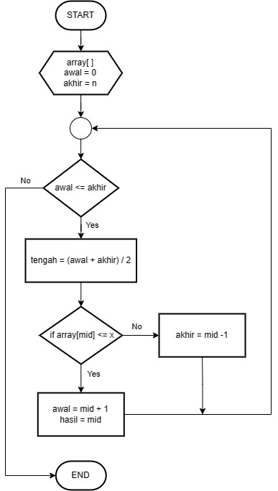

1. Buatlah flowchart dari algoritma sequential search!

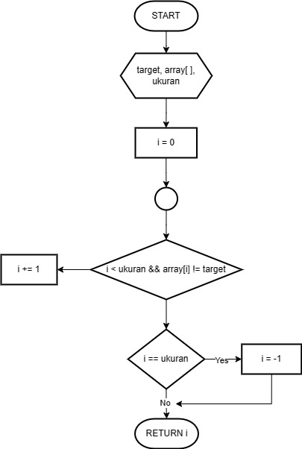

1. Diketahui array sebagai berikut

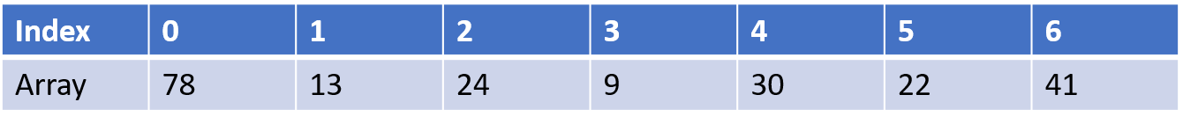

Jika nilai yang dicari adalah 9, maka:

* Gambarkan proses penyelesaian kasus pencarian dengan binary seach (urutkan dahulu array nya dengan algoritma sorting)!

Mengurutkan dengan Bubble Sort secara ascending:

Bubble Sort(arr, size)

for I <- 0 to size-1

for j <- 0 to size-i-1

if arr[j] > arr[j+1]

swap arr[j] and arr[j+1]

return (arr)

Nilai yang dicari = 9

Iterasi 1

|  |  |  |  |  |  |  |  |
| --- | --- | --- | --- | --- | --- | --- | --- |
| Index | 0 | 1 | 2 | 3 | 4 | 5 | 6 |
| Array | 9 | 13 | 22 | 24 | 30 | 41 | 78 |
|  | i |  |  | m |  |  | j |

m = 0 + 6 / 2 = 3, karena 9 < 24 maka posisi j = m - 1

Iterasi 2

|  |  |  |  |  |  |  |  |
| --- | --- | --- | --- | --- | --- | --- | --- |
| Index | 0 | 1 | 2 | 3 | 4 | 5 | 6 |
| Array | 9 | 13 | 22 | 24 | 30 | 41 | 78 |
|  | i | m | j |  |  |  |  |

m = 0 + 2 / 2 = 1, karena 9 < 30 maka posisi j = m – 1

Iterasi 3

|  |  |  |  |  |  |  |  |
| --- | --- | --- | --- | --- | --- | --- | --- |
| Index | 0 | 1 | 2 | 3 | 4 | 5 | 6 |
| Array | 9 | 13 | 22 | 24 | 30 | 41 | 78 |
|  | i  j  m |  |  |  |  |  |  |

m = 0 + 0 / 2 = 0, karena 9 = 9 maka nilai ditemukan.